AI ASSISTED CODING ASSIGNMENT – 16.1
N. SATHWIK (2303A51032)
BATCH-01
Task 1 – Student Information System Schema
Task:
Design a database schema for a Student Information System and generate queries using AI.
Instructions:
• Tables: Students, Courses, Enrollments.
• Define primary keys, foreign keys, and relationships.
• Generate queries:
o Insert a new student record.
o Fetch all courses enrolled by a student.
o Count number of students in each course.
Expected Output:
• SQL CREATE TABLE statements and queries for student–course relationships.
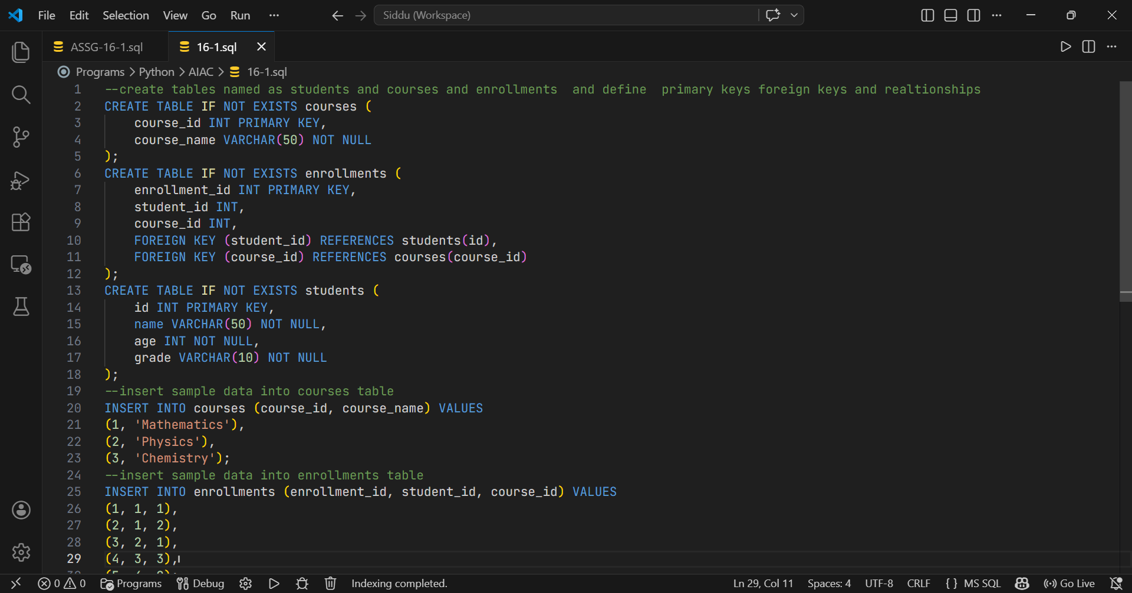

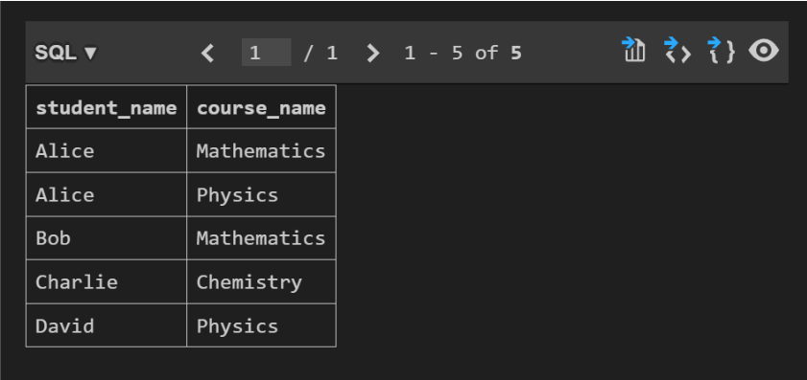
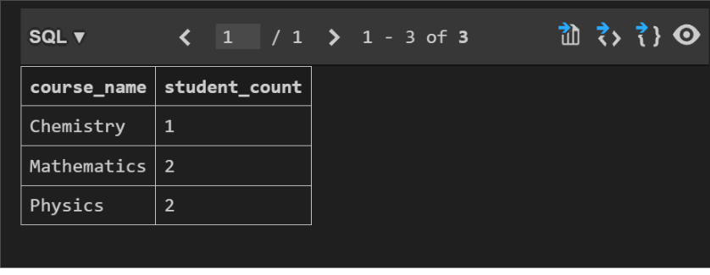
Task 2 – Hospital Management Database
Task:
Create schema and queries for a Hospital Management System.
Instructions:
• Tables: Doctors, Patients, Appointments.
• Use AI to define constraints (unique IDs, valid dates).
• Generate queries:
o List all appointments for a specific doctor.
o Retrieve patient history by patient ID.
o Count total patients treated by each doctor.
Expected Output:
• Normalized schema and SQL queries with joins.
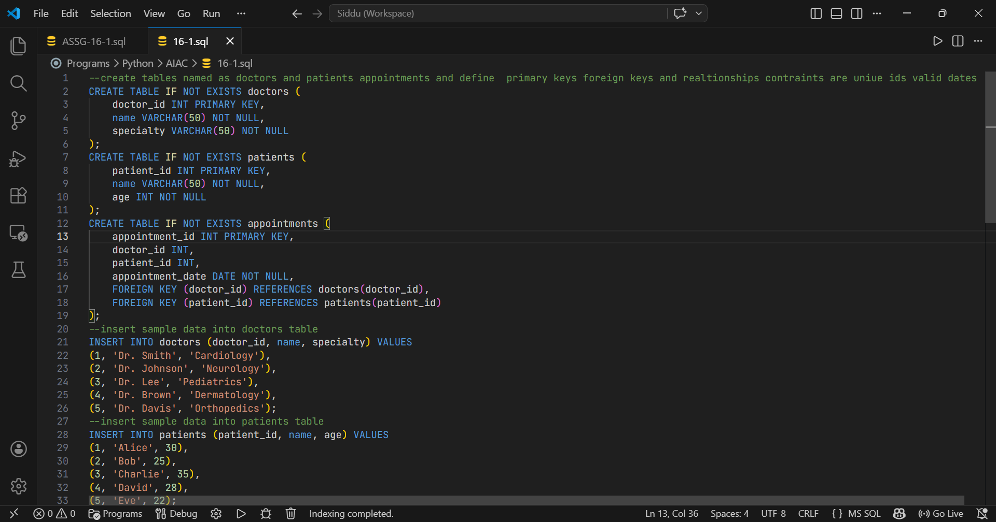
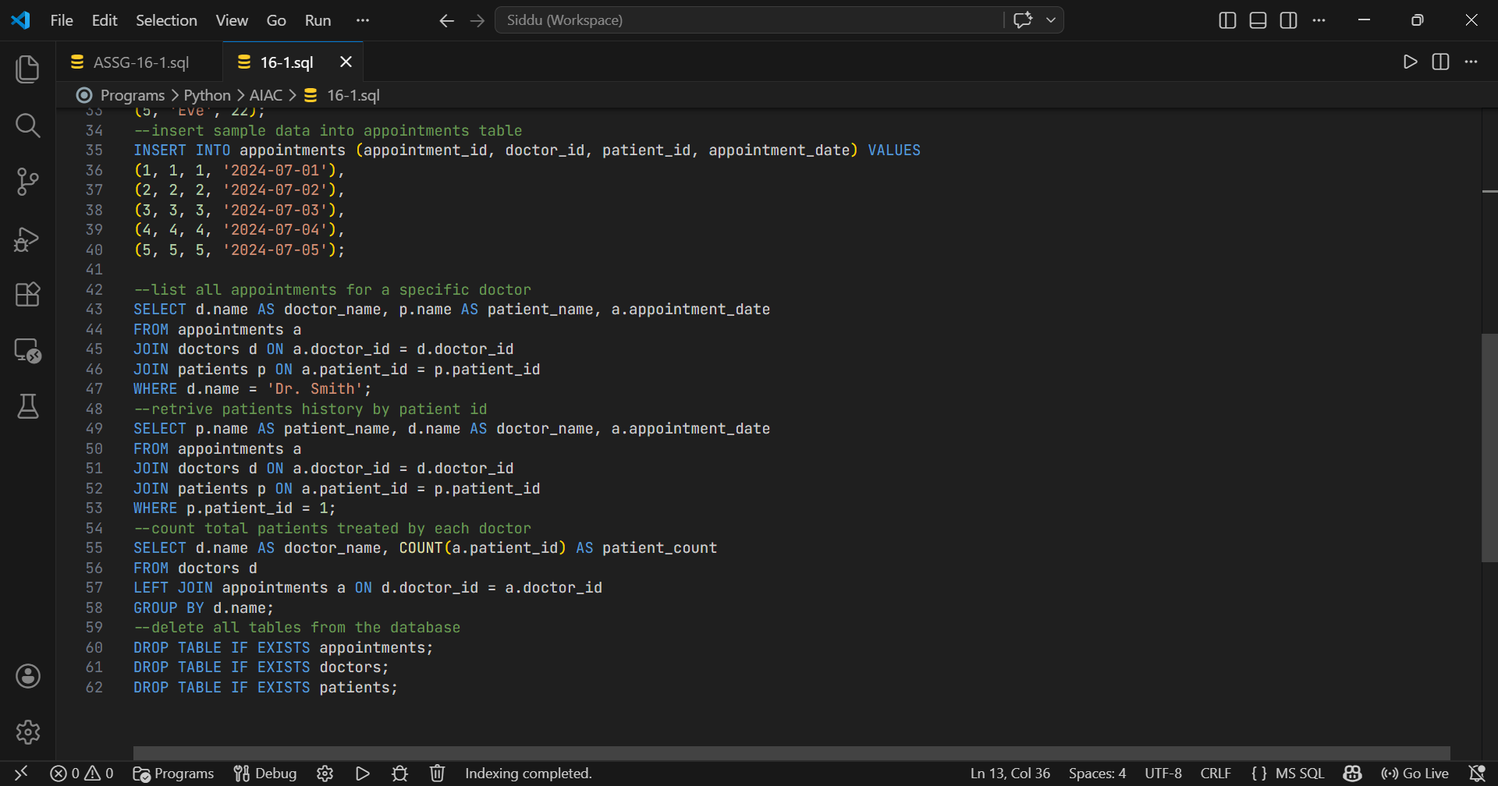
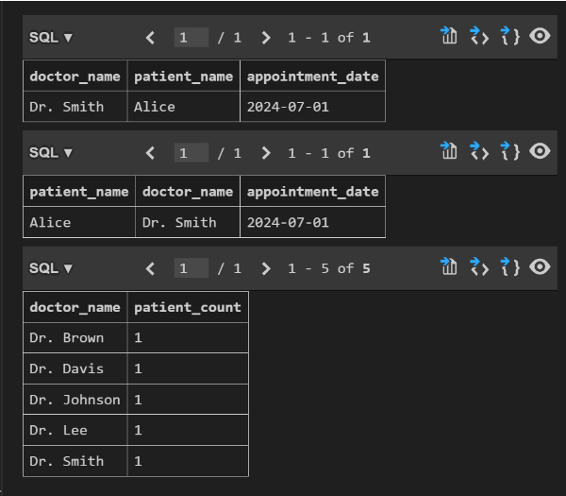

Task 3 – Library Database
Task:
Design schema for a Library Management System.
Instructions:
• Tables: Books, Members, Loans.
• Use AI to suggest indexing strategy for faster queries.
• Generate queries:
o Retrieve all books currently issued.
o Find overdue books (loan date > 30 days).
o Count number of books loaned by each member.
Expected Output:
• Schema + SQL queries demonstrating joins and conditions.
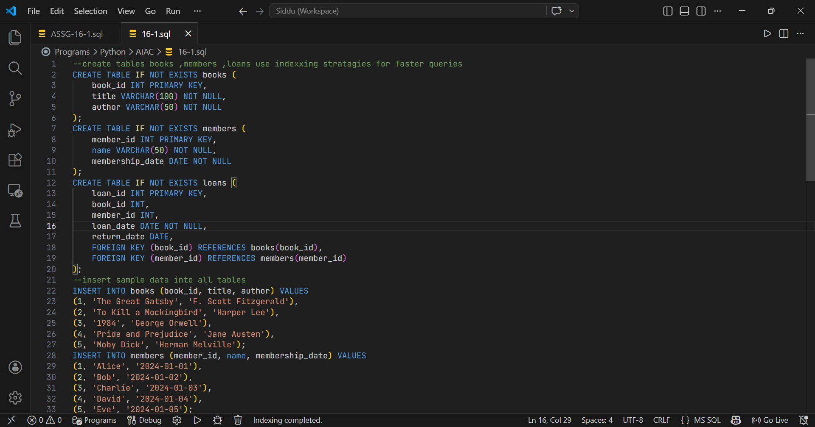
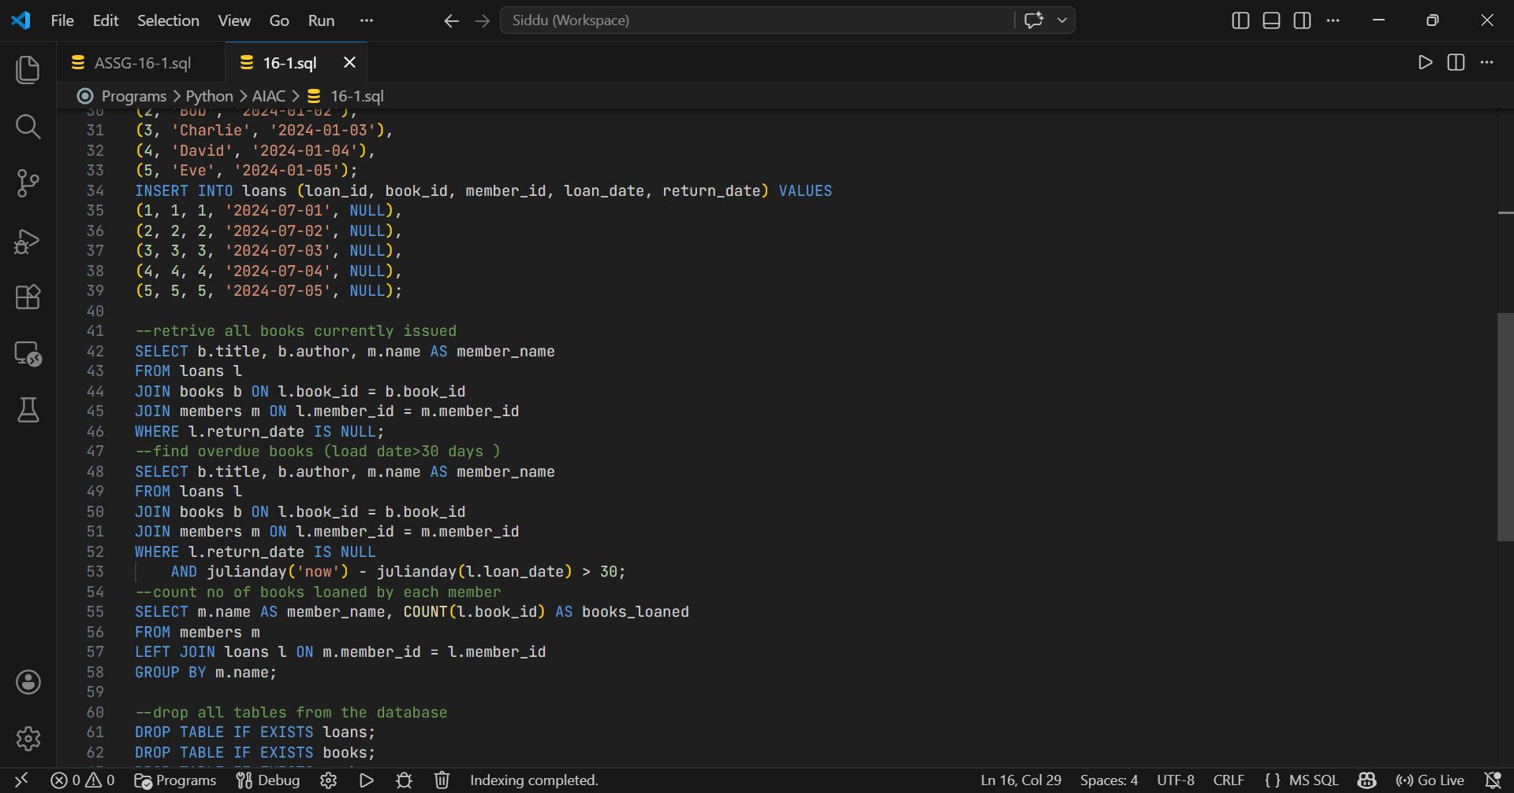
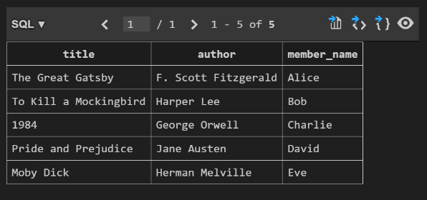
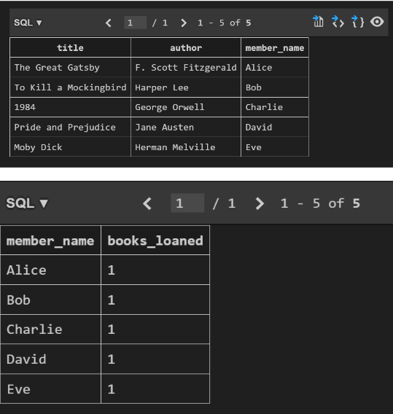

Task 4 – Real-Time Application: Online Shopping Database
Scenario:
Design a database for an E-commerce platform.
Requirements:
• Tables: Users, Products, Orders, OrderDetails.
• Generate queries to:
o Retrieve all orders by a user.
o Find the most purchased product.
o Calculate total revenue in a given month.
• AI should also suggest normalization improvements and query optimization.
Expected Output:
• Complete schema with relationships + SQL queries for
Analytics
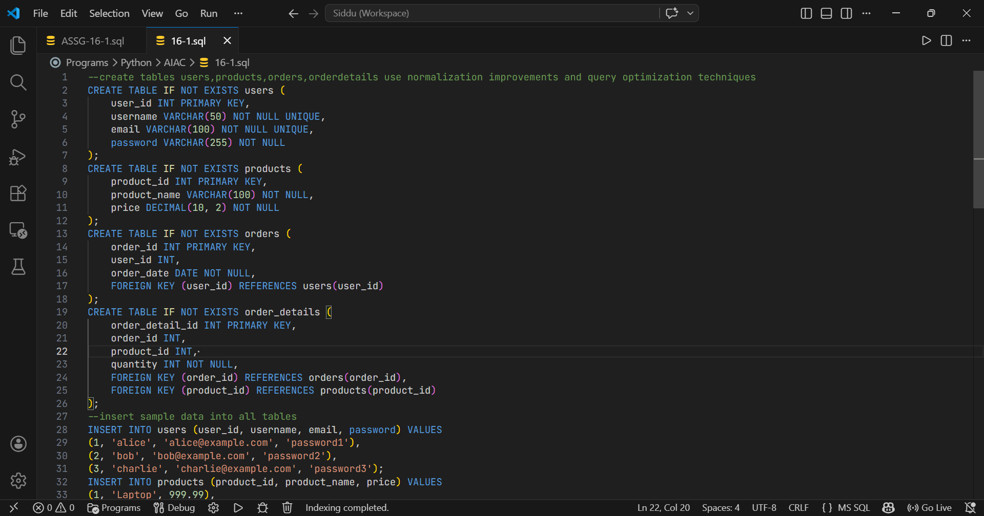
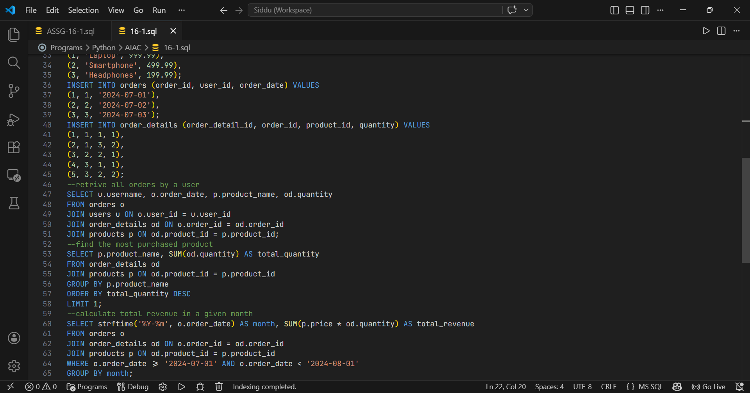
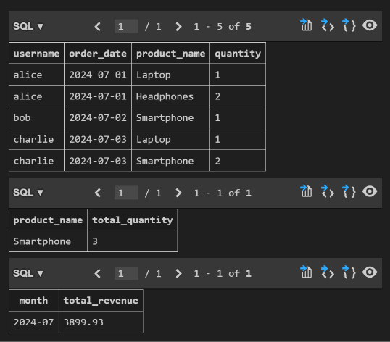

Task 5 – University Examination Database
Design a database schema for a University Examination System and
generate SQL queries using AI.
Instructions:
• Tables: Students, Subjects, Exams, Results.
• Define primary keys, foreign keys, and referential integrity
constraints.
• Generate queries:
o Insert examination results for a student.
o Retrieve subject-wise marks for a student.
o Calculate average marks for each subject.
Expected Output:
• Normalized schema and SQL queries involving aggregation and
joins.

